QUESTION 1

AIM:
To create a table named `STUDENT` with columns `RegNo`, `Name`, `Gender`, `DOB`, `MobileNo`, and `City` using DDL statement.

PROCEDURE:
1. Open the SQL database terminal/client.
2. Execute the `CREATE TABLE` command specifying table name `STUDENT` and defined data types for each attribute.
3. Verify the creation using `DESC STUDENT;`.

CODE / SQL QUERY:

CREATE TABLE STUDENT (
RegNo NUMBER(3),
Name VARCHAR(15),
Gender CHAR(1),
DOB DATE,
MobileNo NUMBER(10),
City VARCHAR(15)
);

Output:
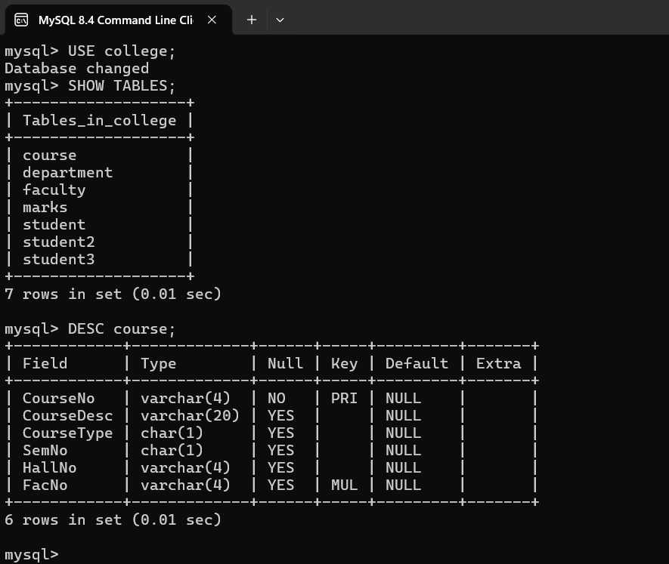

Result
The `STUDENT` table has been created successfully with the required columns and data types.

